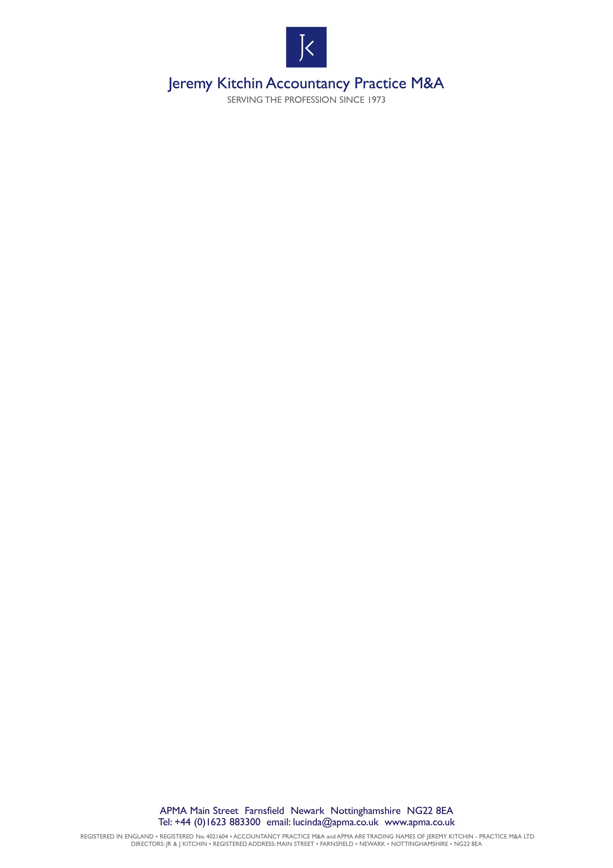

Our Ref: BuyingPackSpecificOpportunity/CurrentJobs

# Please do NOT return this 2-page letter

Dear Sir or Madam

**RE: YOUR INTEREST IN A SPECIFIC SALE OPPORTUNITY WE ARE BROKING**

Because you wish to receive further details of the practice/ fees which we (A.P.M.A.) are broking, below you will find our Practice Acquisition Questionnaire (Buying Pack), which we should be pleased if you would complete and scan, then email (or post) it back to us. At a later stage this information will assist the Vendor(s) in deciding whether they wish to meet you. In the event that this application does not proceed to a satisfactory conclusion, the information may assist us in locating another practice/ fees which meet with your requirements, enabling us to keep you informed of anything which we feel may be of interest to you. We also enclose our Letter of Confidentiality which we require all parties to sign prior to the release of further information on any Vendor’s practice / fees. Please rest assured that until you give permission, we will treat all your information in the strictest of confidence retaining your complete anonymity.

We suggest you keep a copy of your completed Buying Pack on file so that it may be updated easily by yourselves should you wish to register for future buying opportunities.

**An overview of the acquisition process is as follows:**

When you have completed and returned the below two-page registration questionnaire and Letter of Confidentiality, we will then send you the relevant Stats Pack which includes our Terms of Business as well as the Vending firm’s Stats Sheet. This document will enable you to decide whether you wish to proceed to the next stage. If you do, you will be asked simply to complete the document and then send it back. Your signature at that point will then give us permission to forward your profile to the Vendor(s) who will then decide if they wish to meet you.

If they do, we shall arrange for you to attend an initial (‘face fitting’) meeting of just 45-60 minutes on the same day as the other interested parties. Following that, if both parties feel you could do business together and you both wish to explore the opportunity further, you will be invited back to carry out due diligence, often outside business hours, prior to making an offer. **Note**: A.P.M.A. usually helps Purchasers to construct their outline offers, running them past the Vendor(s), ensuring **there is no Dutch Auction**.

A.P.M.A. is usually available to answer any questions you may have, often up to 9pm, seven days per week.

The successful Purchaser and the Vendor are then normally provided with A.P.M.A.’s master Heads of Agreement document complete with instructions, and a 20-30 page draft Sale and Purchase Agreement template, together with other relevant documents and guidance, all of which is provided as part of our service.

For the past almost five decades it has been a seller’s market. In practice this means that there are many more would-be Purchasers than there are opportunities for them to buy. The level of interest in any

practice or block of fees being sold on the open market is, in part, dependent on the density of existing practices within the immediate area. Thus, in a major conurbation, we may receive upwards of 30 applications (of which only some 25% will be serious buyers) for each possible acquisition. In a less densely populated area such as Torbay or Scotland, a lower response would be normal.

The ‘going rate’ at the moment is in the range of 1.0 to 1.2 times the annual recurring fee income; however there is no commercial logic to this standard valuation range. Strangely, accountants seeking to acquire additional fees usually take little account of the benefit to their ‘bottom line’ of a particular opportunity, often gifting the acquisition to their competitor. With the right critical mass and with payroll costs under control, the acquisition could lead to the new owner making 50% net profit with a payback period of under three years – this is worth giving some serious thought to! To be the successful Purchaser, A.P.M.A.’s advice is that you ought to be prepared to pay what the goodwill is actually worth to you, do not just expect to pay an amount within the arbitrary range above. In fact one Purchaser authorized us to go to the market offering up to 1.7 times and was very gratified with the outcome!

Because of this pricing-rut we usually know in advance the price-range that will be paid. The main variables are the payment schedule, the proportion to be paid ‘up front’, the location from which the new owner intends servicing the acquired clients, if, and by how much, (s)he intends to vary the amount charged to the clients, and whether the Vendor(s) believes that the would-be Purchaser’s personality and style of operating is likely to retain the loyalty of the clients. With regard to these issues the abundance of choice afforded to the Vendor(s) usually enables him/ her to be highly selective as to which Purchaser to sell to. **Therefore, it makes sense to spend a little time answering all the questions on the questionnaire, and going ‘that extra yard’ with providing further information, please.**

It is our sincere belief that it is always possible to achieve a situation where both the Vendor(s) and the Purchaser(s) (or the Mergees) are happy with the deal which has been struck; it is simply a question of matching ‘round pegs with round holes’.

If you have any queries, please do not hesitate to contact us. As mentioned earlier, we are usually available by phone until 9pm, which includes most weekends.

Please don’t forget to research our website at [www.apma.co.uk](http://www.apma.co.uk) which has over 45 years of experience promulgated on it in files which are mostly free to access. We particularly recommend you review our ‘successes’ on the ‘[Past](http://www.apma.co.uk/index.php?option=com_content&view=article&id=7&Itemid=9) Sales’ page as well as the Articles page.

Finally, be aware that you are under no contract with A.P.M.A. until, at a later date, you sign our Terms of Business, and then no costs will be incurred by you with A.P.M.A. unless you enter into an arrangement with a party to whom we have introduced you.

Yours sincerely

**for A.P.M.A.**

##### cid:89BBF6A0-9FA2-4C0F-918C-3C201EA2E2CD

**Lucinda Kitchin**

**Director**

Encs. PAQ Questionnaire

Letter of Confidentiality

Services sheet

Page 1/2

**P R A C T I C E / FEES A C Q U I S I T I O N Q U E S T I O N N A I R E**

A.P.M.A.’s Reference No: AP - …………. (Today’s date) ……………………

__________________________________________________________________________________

**PERSONAL INFORMATION**

**CONTACT NAME** ...........................…………..…………………………………………………………………………………………..

**POSITION**...................……....….………………………………………………………………………………………………………………

**PRACTICE NAME**.........................................................…………………………………………………………………………..

**ADDRESS**.....................................................................…………………………………………………………………………..

.........................................................................…………………………………POST CODE...................................

TEL. NO. …………………………………………... MOBILE ………………………………………………………..

E-mail…………………………………………………… PREFERRED METHOD OF CONTACT ……………………………………

**___________________________________________________________________________**

**2. DETAILS OF YOUR OFFICE / FIRM / COMPANY**

**A. Type of Practice:**

1. Sole Practitioner* Partnership* Limited Company* LLP* Registered Auditor? **YES/ NO\***
2. Chartered* Certified* Unqualified* Other* (-state) ………………………………………………………..
3. General, Tax Specialist, Insolvency, etc (type)………………………………………………………………………..
4. Client specialism, i.e. Farmers, Dentists (type) ………………………………….Value: £....………………….
5. Are you running your own practice? **YES/NO\*** Or employed in practice by someone else?

**YES/NO\***  **\*delete or circle**

1. Your estimated annual turnover £……………….
2. Partner/ Director charge out rate? £.………………….per hour/ fixed fee
3. Estimated Gross Payroll Cost? £......…………

D. **How many:** Partners/ Directors inc. yourself? ........…… Partners/ Directors ages? ……………….

Other fee earners?........……………..… Admin staff?.............………………………

Offices have you?...........………………. Clients have you?...……………….....……

Please list office(s) location(s) …………………………………………………………………………

1. Accounts software type?...............………………………………………………………………………………………………..
2. How long has your firm been established for?....…………(years)
3. How long have you worked for this firm? …...…………(years)
4. Do you currently hold a practising certificate? …...………………………………………………………………………..
5. Any other relevant info: …………………………………………………………………………………………………………………

**3. DETAILS OF YOUR REQUIREMENTS**A. What type of firm are you looking for? …………………………………………………………………………………..........

B. Do you wish to purchase / merge / will you consider either? ........………………………….…………………….

(i) Do you insist on integrating the acquired fees into your existing offices? **YES/ NO\***

(ii) Will you consider running the acquisition as a branch office? **YES/ NO\***

C. What is the maximum size acquisition do you wish to make? .............................................................

(Note: suggested funds required for: **fees of** **<£150k = 50% + 33%** (working capital) **up front with balance on 1st anniversary; fees of <£250k = 33% + 33%** (working capital) **up front, plus 33% on 1st & 2nd anniversaries.**)

Page 2/2

D. Geographic location you desire: i.e. commuting time/ distance/ location…………………………………………

E. Do you hope to keep on existing Staff/ Principals? ...........…………………………………………………………………

F. Are you prepared to pay a capital sum for goodwill? ………………………………**YES/ NO\***

G. Will you be borrowing to fund the acquisition? **………** Or do you already have funds in place?  **………**

H. Please briefly state any other parameters: ...…………………………………………………………………………………….

**__________________________________________________________________________________________________________________**

**4. A.P.M.A.’S MARKET RESEARCH INFORMATION** (only if you do not mind)

A. Where did you hear about Accountancy Practice M & A (A.P.M.A.)?

**Previous contact with Jeremy/ Lucinda Kitchin*; advertisement* unsolicited letter*; recommendation*; at a lecture*; website*; other*; don't know\***

B. Have you ever before, either directly or indirectly, been involved in acquiring, selling or merging an

accountancy practice.. **YES/ NO\*** Was it via an **Agent/ Broker/ Privately\***

How would you rate its success? v.successful/ acceptable/ unsuccessful* **\*d*elete as necessary***

How long have you been looking for fees for?…………………………………..(time).

**______________________________________________________________________________________________________________________**

**5. CONSULTANCY FEES** – **FOR INTRODUCTIONS ARE SUBJECT TO ANY SEPARATE AGREEMENT WE MAY ENTER INTO.**

*As an introducing broker, A.P.M.A. will assist you as the Purchaser (or Mergee) as it assists the Selling Principal (or Mergee) and it charges both parties an equal fee which is based on the sum of the anticipated fees sold, bought or merged with. Full details will be conveyed to you on request or sent to you on receipt of this completed questionnaire.*

***This is a NO SUCCESS - NO FEE service***

**NOTE:**

* ***It is sometimes possible to borrow unsecured funds***
* ***You can often get a pay back within 3 years***
* ***If you have fees of c £200k per partner/director/principal, and keep your payroll cost below 33%, you can make 50% net profit on turnover.***
* ***As you are responding to a specific practice / fees, please insert our reference no: AP……………….***

**DON’T FORGET**: please remember to fill in our AP reference (immediately above) and we will send details.

**----------------------------------------------------------------------------------------------------------------------------------**

**In case there is no successful outcome -** please indicate below if you might wish to take an ‘Active’ or ‘Passive’ role as described in the accompanying letter:

\***ACTIVE** (call re undertaking a marketing exercise**) *PASSIVE** (please keep on file) **\*Delete as appropriate**

**SIGNIFY BELOW THAT YOU ARE AWARE THAT IF YOU ACQUIRE A PRACTICE / BLOCK OF FEES FOLLOWING AN INTRODUCTION BY A.P.M.A. YOU WILL BE CHARGED A FEE.**

**BUT, NO CONTRACT EXISTS BETWEEN YOU AND A.P.M.A. UNTIL YOU SIGN OUR TERMS WHICH WILL BE SENT TO YOU UPON RECEIPT OF THIS COMPLETED QUESTIONNAIRE.**

Signed:..................…………………....Title:...........………………………….......Date:...........…………………

Name in Blocks..………...............………….......... Name of Firm.…………………….………………….....…..

By what method would you like to be contacted?………………………………………………………………..

**PLEASE COMPLETE AND RETURN TO**: [lucinda@apma.co.uk](mailto:lucinda@apma.co.uk)

**Or:** Accountancy Practice M&A, 15 Private Street, NEWARK, Notts, NG24 1PL. (Tel: 01623 883300)

**Jeremy Kitchin Practice M&A Limited**

**Main Street**

**Farnsfield**

**Nr Newark**

**Notts NG22 8EA**

**Name of Buyer/Seller**

**Address**

Dear Sirs

**Confidentiality Agreement**

In connection with discussions between us concerning your potential interest in the sale/purchase of [fees/practices (“the Business”). We will be providing to each other confidential information and material, and this letter sets out the terms upon which we will both maintain the confidentiality of any such information and/or material. In this letter, “Receiving Party” means the party receiving or who has received Confidential Material (as defined below) and the “Disclosing Party” means the party disclosing or who has disclosed Confidential Material.

In consideration of our disclosing Confidential Material to each other, we agree the following terms:

1. We will be furnishing each other with information relating to the Business, including in particular, but without limitation, financial information and intelligence pertaining to trade secrets, operations, processes, intentions, products, know-how, designs, market opportunities, operation and strategic planning and suppliers. All such information is referred to in this letter as “Confidential Material”.

2. The fact that the Confidential Material has been delivered to either of us and that we are involved in discussions in any way is confidential.

3. Confidential Material may be transmitted in writing, orally, graphically, electronically or by any other means.

4. We will use the Confidential Material solely for the purpose of our exploratory discussions relating to the Business and any proposals resulting from such discussions and for no other purpose.

5. Both parties will keep all Confidential Material strictly secret and confidential and will not disclose it to anyone save to the potential [Buyer/Seller], our own employees and/or professional advisers to the extent necessary to progress our discussions and/or developing proposals.

6. We will both ensure that:

6.1. we take all reasonable measures to protect the security and confidentiality of the Confidential Material.

6.2. the potential [Buyer/Seller] agrees to abide by the terms of this Confidential Agreement and to keep all Confidential Material strictly confidential.

6.3. all of the Receiving Party’s employees and/or professional advisers who have access to the Confidential Material are aware of its confidential nature and the terms of this letter.

6.4. none of the Confidential Material is left where it may be viewed by anyone not employed by ourselves or by anyone that does not owe us a duty of confidentiality; and

6.5. no Confidential Material is reproduced without the Disclosing Party’s prior written consent.

7. The obligations set out in this letter shall remain in force for as long as the Confidential Material is confidential.

8. Confidential Material shall not include:

8.1. information which is in the public domain.

8.2. information which after its disclosure comes into the public domain other than by reason of any breach of the terms of this letter;

8.3. information which the Receiving Party is able to show was at the date of this letter already in its possession.

8.4. information which the Receiving Party received from any third party on a non-confidential basis provided that such party is not known by the Receiving Party to be bound by any confidentiality agreement with the Disclosing Party in respect of such information; and

8.5. all information which the Receiving Party can demonstrate was generated independently without reference to any information made available pursuant to this Agreement.

9. The Receiving Party may disclose Confidential Material if required to do so to the minimum required by the English Courts, by government agency, or by London Stock Exchange Plc. However, the Receiving Party will, where possible, notify the Disclosing Party before doing so, and will assist the Disclosing Party (at the Disclosing Party’s costs) in any action it may take in opposing the disclosure of any Confidential Material.

10. As soon as the Disclosing Party requests, the Receiving Party will either:

10.1. destroy; or

10.2. return to the Disclosing Party the Confidential Material which is in tangible form, including any copies which the Receiving Party has made together with any abstracts, summaries or references thereto in any documents created by or for the Disclosing Party.

11. The parties agree that all Confidential Material shall remain the property of the Disclosing Party, and that the Disclosing Party may use such Confidential Material for any purpose without obligation to the Receiving Party. Nothing contained herein shall be construed as granting or implying any transfer of rights to the Receiving Party in the Confidential Material, or any patents or other intellectual property protecting or relating to the Confidential Material.

12. If the Receiving party fails to maintain the confidentiality of the Confidential Material, the Receiving Party will indemnify the Disclosing Party for any loss the Disclosing Party suffers as a result.

13. In the alternative to your signature confirming your agreement to the terms of this Confidentiality Agreement you may confirm your acceptance of its terms in writing by email.

Yours faithfully,

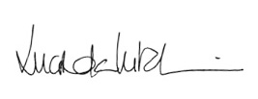

……………………………………………

**Lucinda Kitchin**

**Director**

Buyers/Seller’s Signature

…………………………………..

Name

Date:



**We have been providing M & A Services to accountancy practices, together with valuing goodwill and giving exit route advice, for almost 50 years.**

**SUMMARY OF A.P.M.A.’S SERVICES TO A VENDOR OR MERGEE**

**No Success, No Fee**

* A free and comprehensive consultancy visit, usually for between two and three hours.
* Analysis of your position in the market place and valuation of your practice/goodwill.
* Production of a divestment & information package together with a marketing plan, unless not applicable.
* All marketing undertaken at cost price with confidential handling of all response, retaining your anonymity until such time as you agree to meet the shortlist of purchasers/mergees.
* Interrogation of our substantial Accountancy Practice database in the search for a suitable solution.
* Advice on the production of your client schedule under 12 key headings.
* Removal of 'window shoppers' and 'men of straw'.
* Checking that purchasers are 'in funds', signposting sources of finance if relevant, and confirming they meet the vendor's requirements.
* Presentation of the profiles of the initial shortlist of ready, willing and able purchasers/mergees.
* Organisation of preliminary meetings; providing vendors with an agenda sheet, and an interview pack with suggested questions to be asked, followed by us debriefing all participants.
* Final short listing of up to three purchasers/mergees, in conjunction with the sponsor, and arranging for due diligence by them, usually outside business hours, on the vendor's premises.
* Assisting the finalists in the construction of their outline offers/proposals and helping the sponsor with the selection of the successful purchaser/mergee, followed by rejection of the unsuccessful short listed participants.
* Advising on due diligence and warranties re compliance with the Money Laundering Regulations 2007.
* Advising both parties on the construction of Heads of Agreement, together with the provision of a comprehensive list of relevant commercial clauses.
* Advising on steps necessary to minimise the risk of a claim against the vendor for the loss of fees. (In the past five years, to our knowledge, only once has a purchaser lost as much as 5% of the fees bought.)
* Advising on TUPE - Transfer of Undertakings (Protection of Employment) Regulations.
* Free consultancy advice throughout the whole assignment.

**Absolute confidentiality is assured to all parties so that neither their staff, nor their clients, need know of their plans until they decide to tell them.**

***This could be the biggest financial deal you will ever undertake, so why take a risk?***